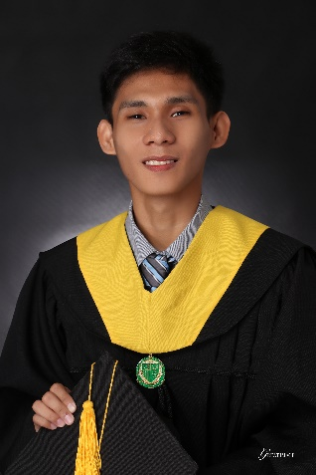**JESSIE JOHN F. MORBOS**

Web Designer,

[morbosjessiejohn@gmail.com](mailto:morbosjessiejohn@gmail.com)

morbosj.github.io/jdev

B19 Earth St. F. Santiago Brgy. Parada Valenzuela City

+639472727976

**OBJECTIVE**

To be part of your company that provides an opportunity to capitalize my technical skills and abilities in the field of Information Technology (IT) and also to work well with other people.

**SKILLS**

* Used Adobe XD and Adobe Photoshop to handle all web design.
* Proficient in; HTML, CSS, PHP, Javascript and jQuery.
* Redesign the functionality of a website with changing its look.
* Developing a new visual style, redesigning the website.
* Expertise in troubleshooting, building of hardware systems and software applications.

**EDUCATIONAL BACKGROUND**

**OUR LADY OF FATIMA UNIVERSITY**, Valenzuela Campus

Bachelor of Science in Information Technology, SY 2015 - 2019

**WORK EXPERIENCE**

FATIMA UNIVERSITY MEDICAL CENTER, Valenzuela City

Technical Support, June 2018 – October 2018

Installing, Printer Repair, Troubleshooting computer and use of system called BizBox HIS, MMS.

On-the-job Trainee

**AWARDS AND ACHIEVEMENTS**

* 2nd Place in Web Development, CS IT OLYMPICS (2017)
* Champion in the Web Programming, CSS OLYMPICS INTERCAMPUS (2017)
* Passing Microsoft Trends and Technology Achiever (MARCH 07, 2019)

**SEMINAR**

* Game Development and Microsoft Technologies, STRUCTURED PROGRAMMING LANGUAGE SYMPOSIUM 2015
* Reshaping Education using Blended and Flipped Learning, TECH TUTOR 7 (2015)
* Bridging the Gap between Business and Education, TECH TUTOR 8 (2016)
* Fostering Startup Culture in the Academe Towards a Richer Philippines, 7th PSITE-NCR STUDENT CONGRESS (2019)

**CHARACTER REFERENCE**

**KRYZIEL MAE MORBOS**

SAN-YANG INTERTRADE CORP. – SALES ACCOUNTING

+639353737295

**Nicole Dan B. Pacomio**  
Fatima University Medical Center – IT Supervisor

+639055142716

*I hereby cetify that all the above information is true and correct.*

**JESSIE JOHN FLORES MORBOS**